**WATER QUALITY ANALYSIS**

**Introduction:**

 Water quality analysis is also called hydrochemical analysis. That is to use chemical and physical methods to determine the content of various chemical components in water. Water quality analysis can be divided into three types: simple analysis, complete analysis and special analysis.

The project involves analyzing water quality data to assess the suitability of water for specific purposes, such as drinking. The objective is to identify potential issues or deviations from regulatory standards and determine water potability based on various parameters. This project includes defining analysis objectives, collecting water quality data, designing relevant visualizations, and building a predictive model.

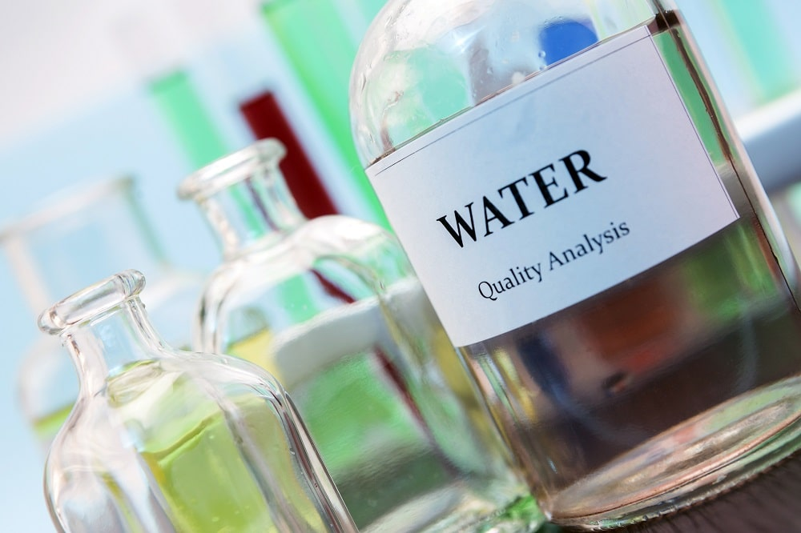

**Data Source:**

**A good data source for water quality analysis should be accurate,complete,covering**  **the geographic area of interest, Accessible.**

**Dataset link:**

[**https://www.kaggle.com/datasets/shreyanshverma27/water-quality-testing**](https://www.kaggle.com/datasets/shreyanshverma27/water-quality-testing)

|  |  |  |  |  |  |
| --- | --- | --- | --- | --- | --- |
| Sample ID | pH | Temperature (Â°C) | Turbidity (NTU) | Dissolved Oxygen (mg/L) | Conductivity (ÂµS/cm) |
| 1 | 7.25 | 23.1 | 4.5 | 7.8 | 342 |
| 2 | 7.11 | 22.3 | 5.1 | 6.2 | 335 |
| 3 | 7.03 | 21.5 | 3.9 | 8.3 | 356 |
| 4 | 7.38 | 22.9 | 3.2 | 9.5 | 327 |
| 5 | 7.45 | 20.7 | 3.8 | 8.1 | 352 |
| 6 | 6.89 | 23.6 | 4.6 | 7.2 | 320 |
| 7 | 7.19 | 21.2 | 4.2 | 8.8 | 350 |
| 8 | 6.98 | 22.1 | 3.7 | 6.9 | 325 |
| 9 | 7.31 | 20.4 | 4.1 | 8.4 | 360 |
| 10 | 7.02 | 22.7 | 4.8 | 7.5 | 330 |
| 11 | 7.24 | 22.4 | 4.3 | 8.6 | 347 |
| 12 | 7.17 | 21.6 | 3.6 | 7.1 | 328 |
| 13 | 6.95 | 22.3 | 4.1 | 6.4 | 341 |
| 14 | 7.06 | 23.5 | 3.7 | 9.2 | 355 |
| 15 | 7.48 | 20.8 | 3.4 | 7.9 | 329 |
| 16 | 6.92 | 21.4 | 4.9 | 6.8 | 362 |
| 17 | 7.11 | 22 | 4.4 | 8.1 | 336 |
| 18 | 7.3 | 23.2 | 3.5 | 9.6 | 351 |
| 19 | 7.13 | 21.1 | 4 | 7.5 | 319 |
| 20 | 7.01 | 23 | 4.7 | 8.9 | 330 |
| 21 | 6.83 | 22.5 | 3.3 | 6.1 | 348 |
| 22 | 7.34 | 20.3 | 4.2 | 8 | 365 |
| 23 | 7.16 | 23.4 | 4.5 | 7.7 | 326 |
| 24 | 7.25 | 22.6 | 3.9 | 9.1 | 355 |

**Water Quality Consideration:**

* **Irrigation**
  + **pH**
  + **Conductivity**
  + **Sodium & Potassium**
  + **Nutrients**
  + **Specific compounds**
* **Industries**
* **As per specific requirement**
* **Domestic Consumption**
* **As per BIS Standards**
* **Water Bodies**
* **As per CPCB guidelines**

**What are the steps in water quality analysis?**

**Common steps in involved in water quality analysis are**

* **Data preprocessing,**
* **Data splitting model training and testing**
* **pH Testing Procedure:**

**Rinse each test tube with the water sample. ...**

**Fill the tube to the 5mL line with sample water.**

**While holding a dropper bottle vertically, add 10 drops of Wide Range Indicator Solution.**

**Cap and invert several times to mix.**

**Insert the tube into the Wide Range pH Comparator. ...**

**Record the pH value.**

* **Water analysis report:**

**It will contain a list of contaminants tested, the concentrations, and, in some cases, highlight any problem contaminants. An important feature of the report is the units used to measure the contaminant level in your water. Milligrams per lit (mg/l) of water are used for substances like metals and nitrates**

* **Good water quality:**

**Good water quality is determined by its “lack of impurities,” that is, lack of contaminants. Water pollution can occur when physical or chemical contaminants enter the water source, thus becoming a potential risk for human health and even transmitting several dangerous**

* **Test of water purity:**

**To test the purity of water at home, buy a home testing kit and dip each testing strip into a glass of tap water. Use the chart that came with the kit to determine your water quality. If you don't have a kit, smell, taste, and inspect the water.**

* **Chlorine:**

**Chlorination is one of sterilization method in drinking water and industrial water, and chlorine measurement is very important to secure water quality. You can find the best solution thanks to unique Apure technologies proven by experiences.**

* **Turbidity :**

**Turbidity analyzers was developed for controlling and monitoring drinking water, a turbidity measurement is also required in wastewater plant more and more to achieve sustainable society. Provide safe water and save water pollution.**

* **Salinity:**

**Salinity Meter is an instrument used to quickly determine the concentration or refractive index of saline solution by weight. Widely used in salt, food, beverage and other industrial sectors and agricultural production.**

**Conclusion:**

**Pollution is a deterioration of water quality caused by human agencies that makes the water less suitable for use than it was originally.**